Travelling / Holidays

Obligatory / Do without

Diversify / upgrade

Itinerary / in the heat of the moment, spontaneously

Full board / half board

Self-catering/package

Off peak / peak

Cautious /hazardous

rush/take your time

- Savour in / indulge in

- expose / cool off in the shade / unwind

- get away from it all / take your mind of / set your mind on

- off the beaten track / overcrowded /

- holiday of a lifetime

**Adjectives:**

**Positive:**

**,vibrant , stunning, well-connected , outstanding, competitive, unspoilt, off-peak, unique, breathtaking, luxurious, flying , well-equipped, attentive**

**………………………city**

**………………………** prices

……………………..buildings

………………………..visit

………………………. nature

………………………. views

………………………. conditions

………………………. landscapes

………………………. hotels

………………………. service

Holidays - negative

**, shabby , moldy, disgusting , defective/faulty , shortage of , leaking , sluggish , jet-lagged , smelly**

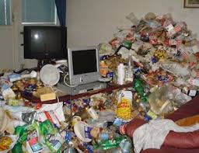………………………………………..room

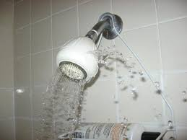……………………………………….shower

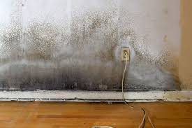……………………………………..walls

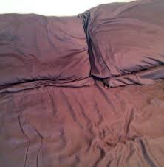………………………………..linen

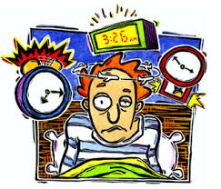Feeling …………………………….

…………………………………….staff

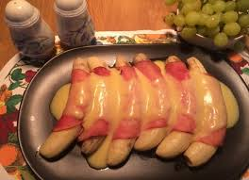……………………………………..food

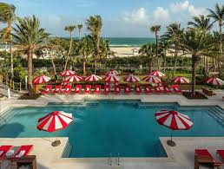………………………………………facilities

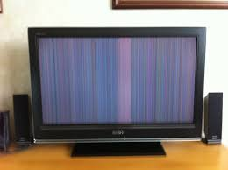……………………………………….devices

**Verbs**

**venture, hike, wander, stroll , expose, purchase, cool, camp, admire, explore, socialize**

…………………………in the mountains

…………………………… around the city

…………………………with natives

……………………………. into unknown places

……………………………. your body to the sun

……………………………… souvenirs

…………………………….. nature

……………………………. off in the shade

…………………………….. near the lake

……………………………..monuments

I am keen on…………………

……………………………….appeals to me

I fancy ………………………………..rather than………………………….

I am in the habit of …………………..

I am passionate about ………………………

Attach a lot of attention to ………………………….

I devote a lot of time to………………………

* C- Make/ reservation , vacancies/ July ?
* R- available , staying
* C - staying
* R - Type/room
* C - Single/twin
* R- Breakfast
* C- Breakfast
* R- Overlooking
* C- rate/ overlooking
* R- rate